Test Case: tc001_SPX_Dev5_Crear_Requisicion_Spot_Tipo_Cobro_CC
Step 1 - Enter username and password and click to button Enter : Credentials Entered
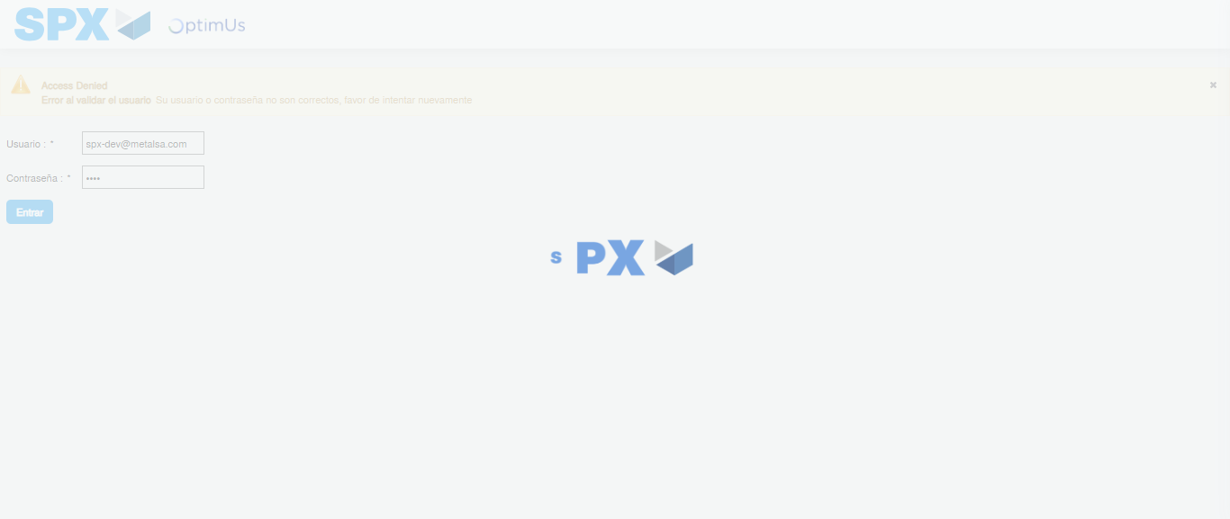Image file-name: QC_Testing-tc001_SPX_Dev5_Crear_Requisicion_Spot_Tipo_Cobro_CC-1783983860007

Step 2 - Select to UEN and Access to Spot Buy Requisitions : UEN Correctly selected and Correct access
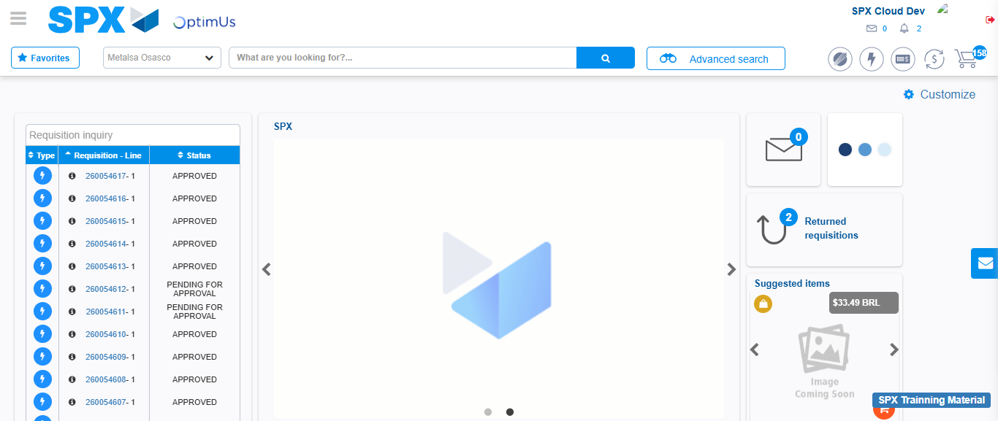Image file-name: QC_Testing-tc001_SPX_Dev5_Crear_Requisicion_Spot_Tipo_Cobro_CC-1783983885717

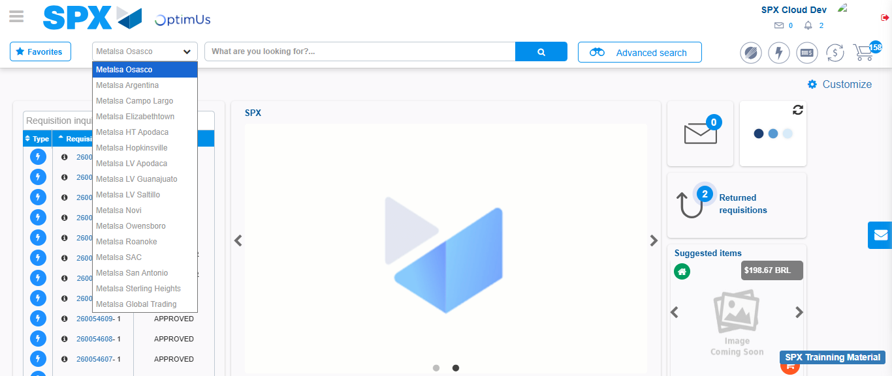Image file-name: QC_Testing-tc001_SPX_Dev5_Crear_Requisicion_Spot_Tipo_Cobro_CC-1783983888279

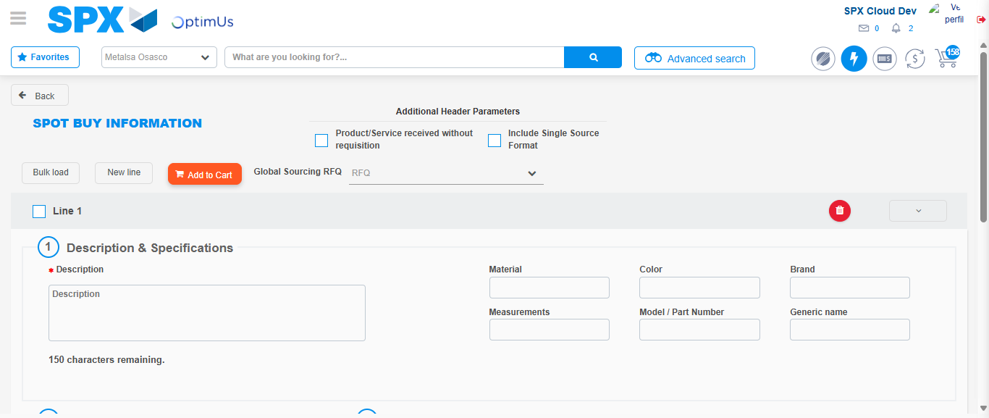Image file-name: QC_Testing-tc001_SPX_Dev5_Crear_Requisicion_Spot_Tipo_Cobro_CC-1783983915295

Step 3 - Data Capture Spot Buy Requisition : Data captured correctly
Image file-name: QC_Testing-tc001_SPX_Dev5_Crear_Requisicion_Spot_Tipo_Cobro_CC-1783983915504

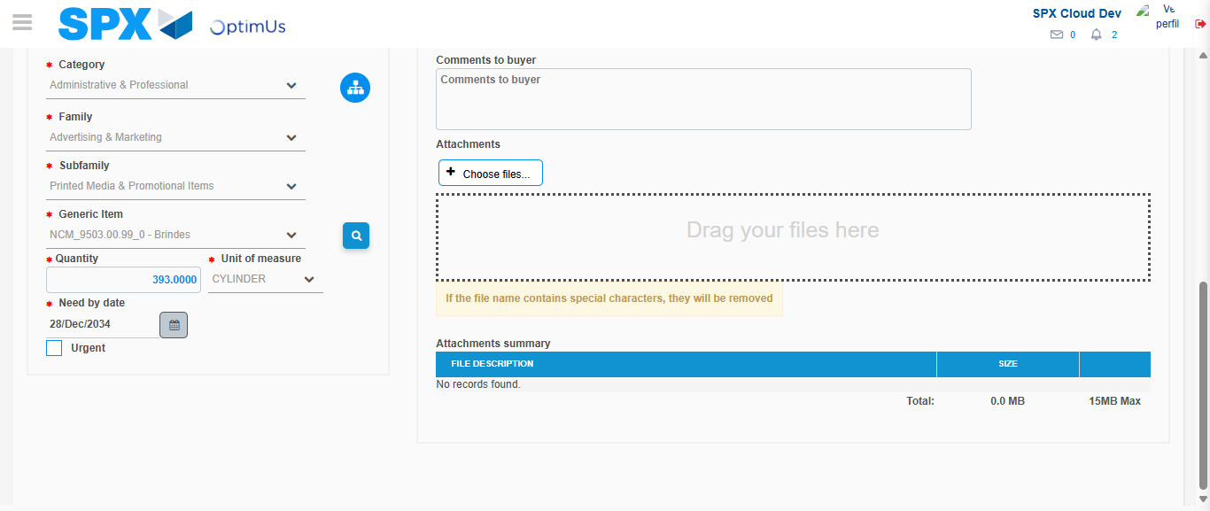Image file-name: QC_Testing-tc001_SPX_Dev5_Crear_Requisicion_Spot_Tipo_Cobro_CC-1783983926905

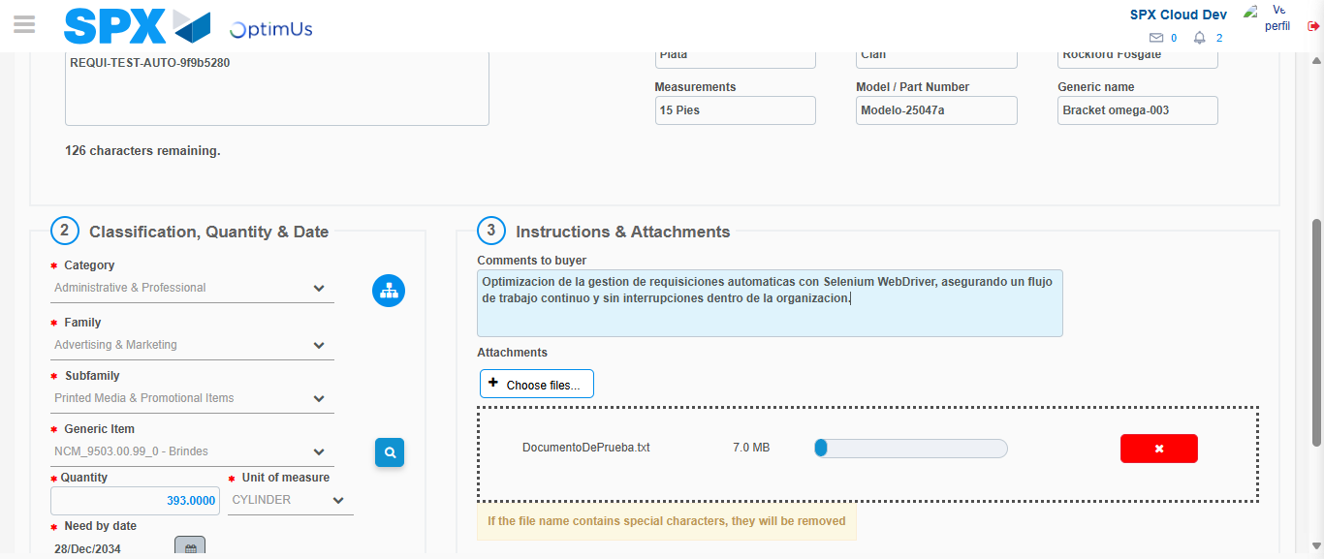Image file-name: QC_Testing-tc001_SPX_Dev5_Crear_Requisicion_Spot_Tipo_Cobro_CC-1783983927684

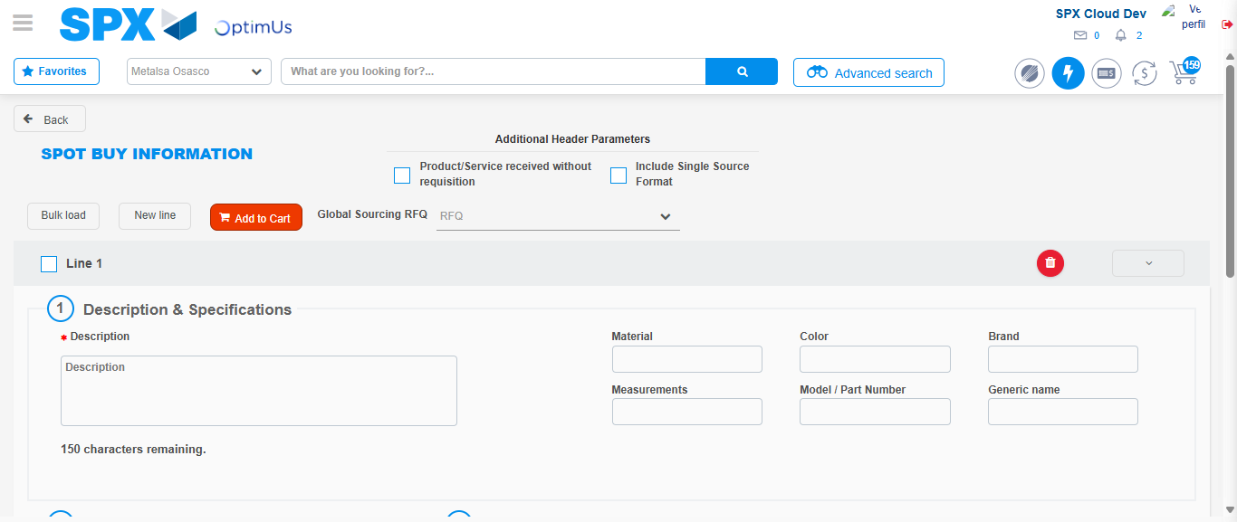Image file-name: QC_Testing-tc001_SPX_Dev5_Crear_Requisicion_Spot_Tipo_Cobro_CC-1783983940739

Step 7 - Return to Main Page SPX : Return to Main Page SPX
Image file-name: QC_Testing-tc001_SPX_Dev5_Crear_Requisicion_Spot_Tipo_Cobro_CC-1783983885717

Image file-name: QC_Testing-tc001_SPX_Dev5_Crear_Requisicion_Spot_Tipo_Cobro_CC-1783983888279

Image file-name: QC_Testing-tc001_SPX_Dev5_Crear_Requisicion_Spot_Tipo_Cobro_CC-1783983915295

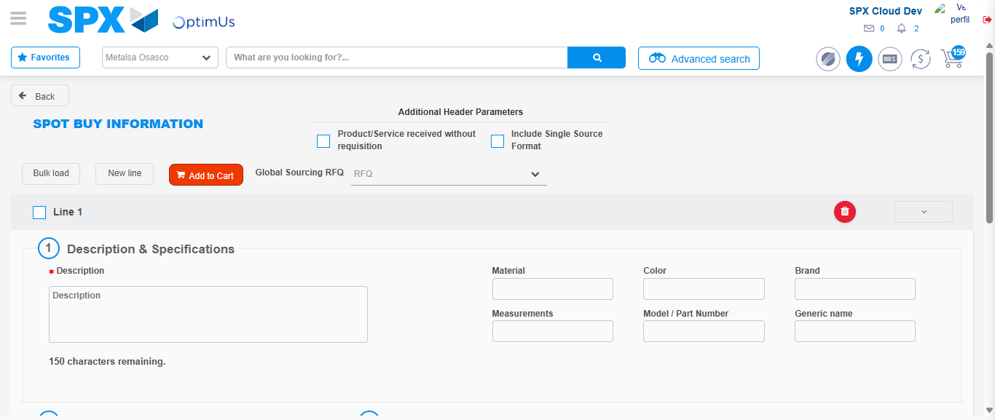Image file-name: QC_Testing-tc001_SPX_Dev5_Crear_Requisicion_Spot_Tipo_Cobro_CC-1783983942958

Image file-name: QC_Testing-tc001_SPX_Dev5_Crear_Requisicion_Spot_Tipo_Cobro_CC-1783983943138

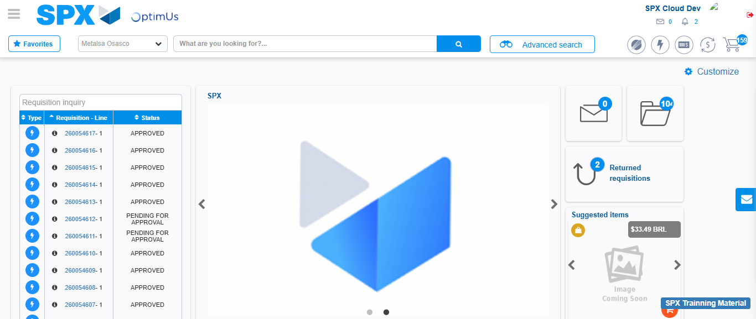Image file-name: QC_Testing-tc001_SPX_Dev5_Crear_Requisicion_Spot_Tipo_Cobro_CC-1783983964072

Step 8 - Log Out : Log Out SPX
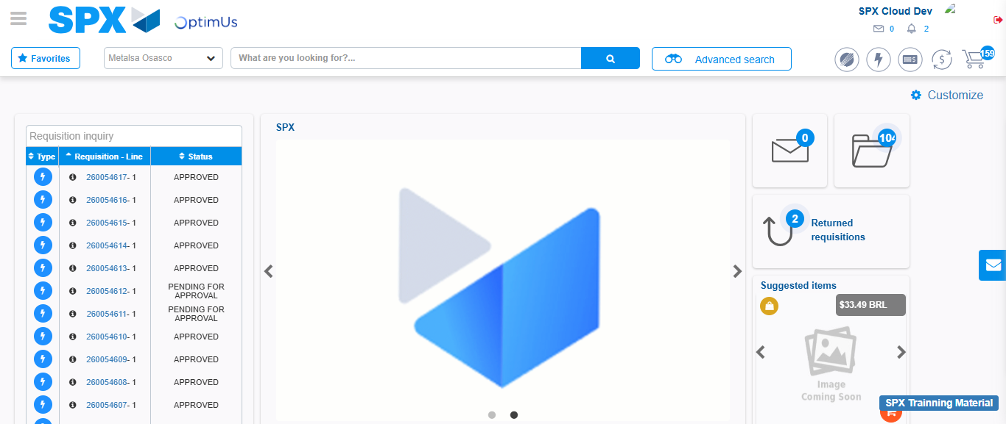Image file-name: QC_Testing-tc001_SPX_Dev5_Crear_Requisicion_Spot_Tipo_Cobro_CC-1783983964371

